Denver-Based Team, wins Blockchain Hackathon with Homeless Solution

WolfPack’s breakthrough solution awarded at ETHDenver provides an accessible labor market, identification, work history, wage theft protection, and financial empowerment to the homeless.

DENVER, TBD — WolfPack, a project by Indigo Theory wins Impact Award at ETHDenver on Feb 16,2020 for their blockchain project to help the homeless. The team also won a UX Award, and Celebrity’s Choice Award by the co-founder of Ethereum, Vitalik Buterin.

Projects submitted to the impact track required meeting the United Nations Sustainable Development Goals . The top 5 projects shared equally in a prize pool of $12.2K in ETH (Ethereum) equivalent.
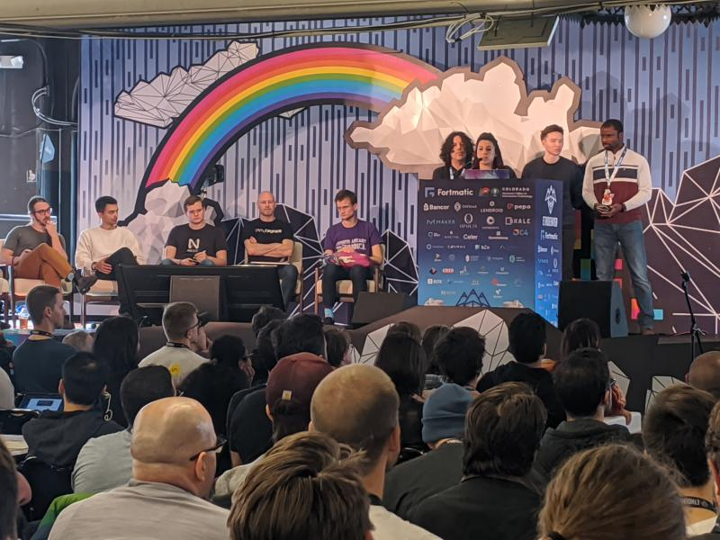
WolfPack is comprised of UX Designers Alex Gardner and William Sterling, and developers Konstantin Papkovskiy and Arnaud Konan. Motivating the team behind the project is what is currently happening in cities across the country. Citing San Francisco as Denver’s future, “you can’t just throw money at the symptoms of homelessness. It’s a human problem that requires a Human Centered Design solution,” stated Gardner.
“We made many good connections over the past year,” said Sterling. “We interviewed seven nonprofit organizations, spoke with several city council members, talked with many of Denver’s homeless and conducted over 100 hours of independent research.”
Watch the video featuring the winning team and their research.

The dedication to solving this problem was evident when they delivered their passionate, final presentation at the Denver Sport’s Castle to a gathering of hundreds of today’s brightest and creative minds using blockchain to build a better future.
“People living on the street have little protection. Most want to work, but are vulnerable to wage theft and discrimination for simply being homeless,” said Gardner. “This is a disincentive to work and only perpetuates the cycle of homelessness. The Wolf Pack platform would secure their earnings and provide a method of identification — another thing most of us take for granted.”
Walking out of the venue late Sunday evening, after three days of little sleep and diligent building, the team left jubilant. “I have to admit, it’s pretty exciting and reaffirming to have the community feel so strongly about a project we’ve invested so much time and empathy into,” said Sterling.
WolfPack is currently seeking potential vendors and employers willing to pilot their platform. For more information and to register for the pilot, visit www.indigotheory.io. Media requests please reach out to William Sterling, bill@indigotheory.io.

###
About Wolf Pack
Wolf Pack is a Web3 blockchain solution for Denver’s unhomed community. A project of Indigo Theory, Wolf Pack aims to take a Human Centered Design approach to solving a problem by understanding the end user’s needs. By creating a positive reward system, data collection and empathetic approach, Wolf Pack demonstrates that an investment in our homeless individuals can be more than a continuation of symptoms but instead a revolutionary approach to civic engagement.
Media Contact: William Sterling, UX Designer
303.704.7854, bill@indigotheory.io

